CUHK International Student Summit (ISS) 2018

With the theme “Technology Start-ups, Business Environment for SMEs, and Society”, the CUHK International Student Summit (ISS) was a three-day summit for elite university students from different countries. The ISS aimed to encourage cultural and intellectual exchanges between students from different nationalities, as well as foster their understanding on global business environment through research and presentation activities.

By participating in ISS, students had the opportunity to engage in a wide variety of activities, including firm visits in Shenzhen, guest sharing and poster presentation.

Date: 10 – 13 May 2018

Place: CUHK Campus and Wu Kwai Sha Youth Village, YMCA Hong Kong

Participants: 29 university students and faculty members from Hong Kong, Macau, Taiwan, mainland China, Thailand and Brunei.

Day 1

The Open Ceremony of ISS was held at 2:30pm in Cheng Yu Tung Building, CUHK. Participants was welcomed by Prof. Travis Ng, Director of APEC Study Centre, CUHK. Prof. Ng shared his valuable insights on the impact of technology on business and also encouraged young participants to explore.

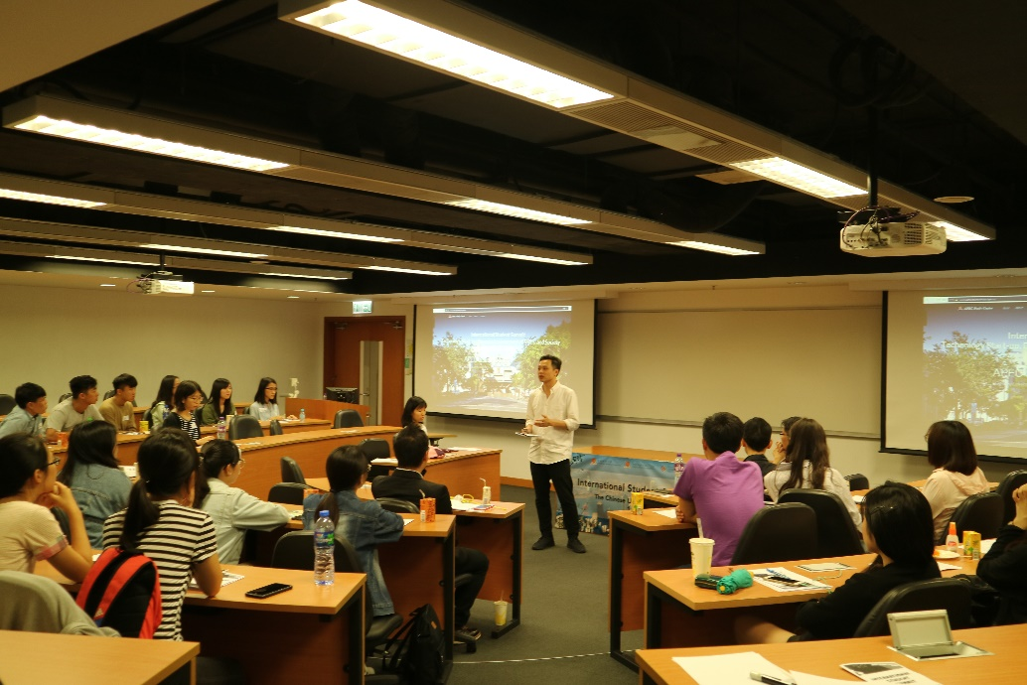

Team building activities and other events were hosted in the beautiful campus of CUHK, and a BBQ dinner to connect participants from various countries and places was held in Wu Kwai Sha Youth Village, YMCA Hong Kong.

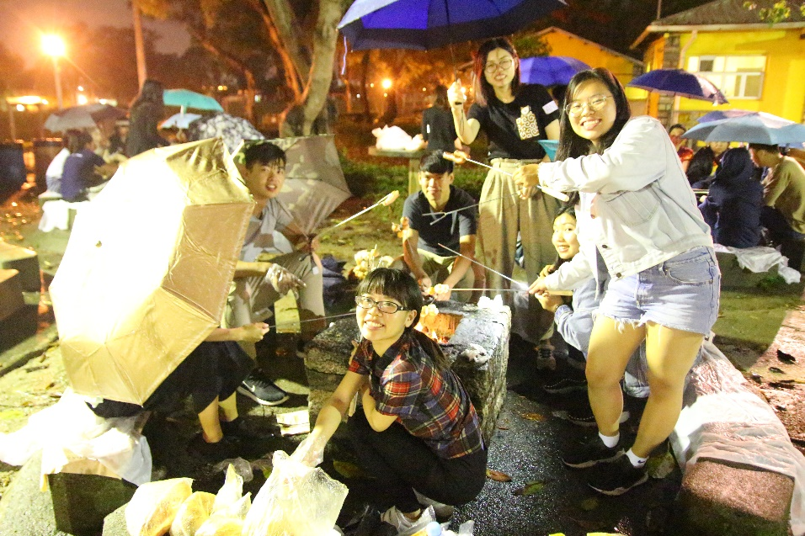

Day 2

Visits were arranged on Day 2. In the morning, participants first took the shuttle bus to Qianhai Headquarter (前海), Shenzhen, to learn about the rapid development of startup environment and incubation in the Southern part of China.

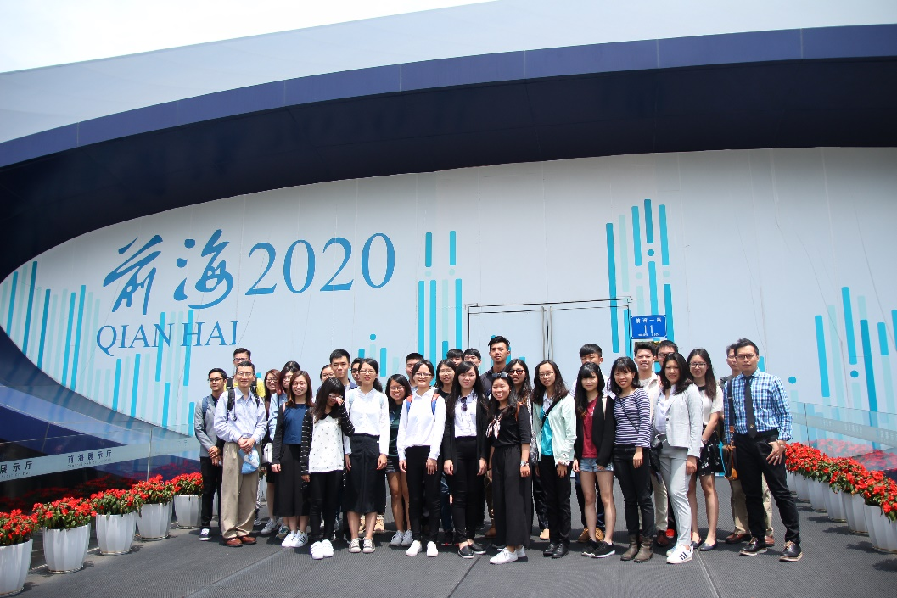

Then in the afternoon, a visit to Tencent (騰訊) headquarter was arranged. Participants not only could visit the Tencent new headquarter, which was a combination of the latest design and technology, but also had the opportunity to learnt about the development and business strategies of one of the biggest and most successful technology firms in mainland China.

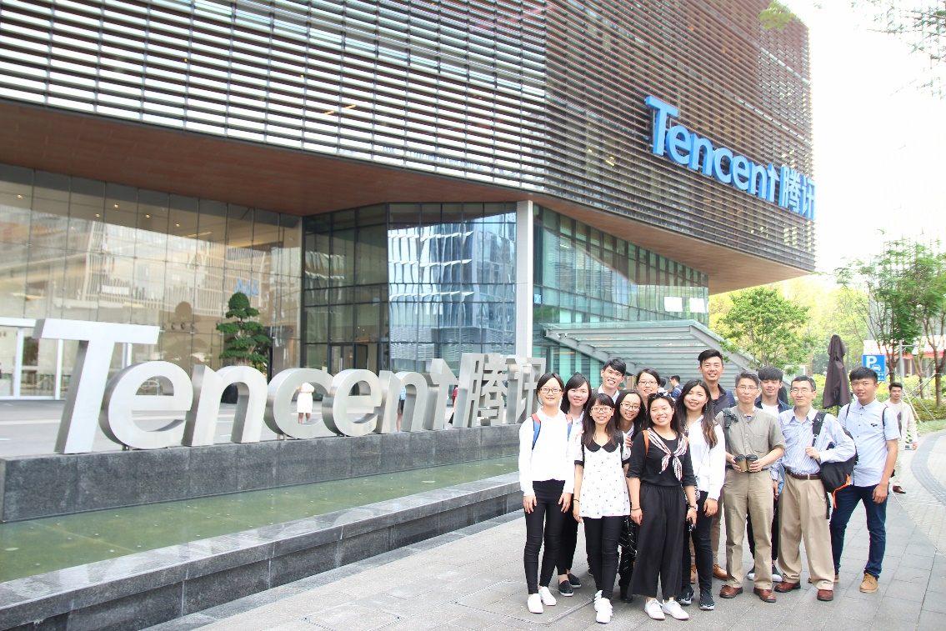

Day 3

On Day 3, teams presented their findings of their research study on local technology start-ups. They documented the story of a selected technology startup from their country / region, analysed the reasons for their successes, and proposed ways to move forward.

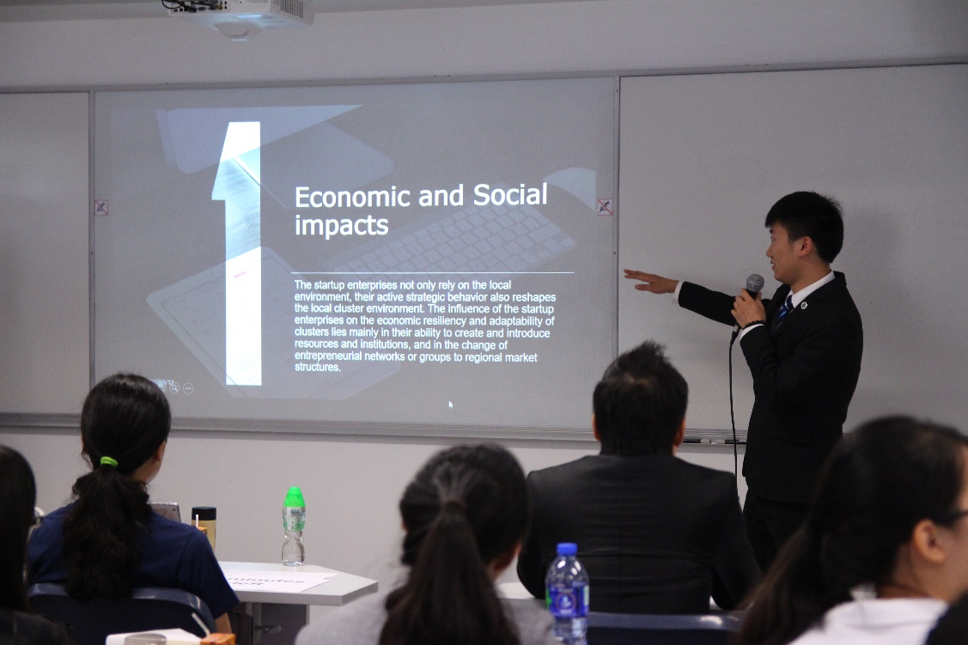

A guest sharing was also arranged. Mr. Keith Wong, an entrepreneur who was also a graduate of CUHK MBA programme, shared with all participants the startup environment in Hong Kong, as well as his thoughts and experience of his own start-up journey.

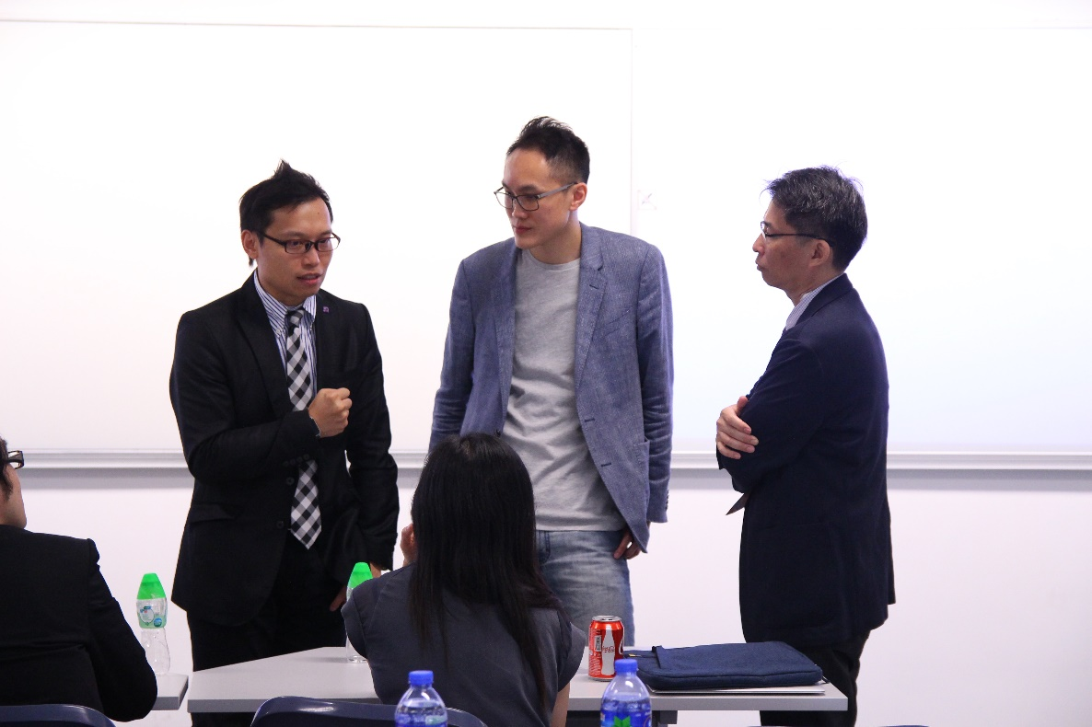

The CUHK International Summit 2018 was a successful event. Participants found it eye-opening and they treasured the opportunities to learn about the latest development in technology startups in both Hong Kong and Shenzhen. The cultural exchange among participants from various places was also invaluable.

